**MAT1011 – Calculus for Engineers (MATLAB), Fall Semester 2020-2021**

**Digital Assignment SL. 10, Experiment – 5B: Line integral and work done**

**By: Jonathan Rufus Samuel (20BCT0332) Date: 17.12.2020**

__________________________________________________________________________________

**Q1) Write the program for the line integral ∫c F.dR along the given curve C, given by x(t) = t = sin(pi*t/2), y(t) = t = cos(pi*t/2), 0<=t<=1, where F = x*y^2 i + (x^2)*y j. (HERE x(t) = t = sin(pi*t/2) AND y(t) = t = cos(pi*t/2), AS MENTIONED IN THE DA QUESTION PAPER, NOT FROM THE LAB MANUAL)**

A: Code is as follows:

%Write the program for the line integral ∫c F.dR along the given curve

% C, given by x(t) = t = sin(pi*t/2).

% y(t) = t = cos(pi*t/2), 0<=t<=1, where F = x*y^2 i + (x^2)*y j

clc

clear all

syms x y t

f=input('Enter the components of 2D vector function [u,v] ');

r=input('Enter x,y in parametric form');

I=input('Enter the limits of integration for t in the form [a,b]');

a=I(1);b=I(2);

dr=diff(r,t);

F=subs(f,{x,y},r);

Fdr=sum(F.*dr);

I=int(Fdr,t,a,b)

P(x,y)=f(1);Q(x,y)=f(2);

x1=linspace(-2*pi,2*pi,10); y1=x1;

[X,Y] = meshgrid(x1,y1);

U=P(X,Y); V=Q(X,Y);

quiver(X,Y,U,V,1.5)

hold on

t1=linspace(0,2*pi);

x=subs(r(1),t1);y=subs(r(2),t1);

plot(x,y,'r')

**Output (via Command Window):**

Enter the components of 2D vector function [u,v]

[x*y^2 x^2*y]

Enter x,y in parametric form

[t=sin((pi*t)/2) t=cos((pi*t)/2)]

[t=sin((pi*t)/2) t=cos((pi*t)/2)]  
 ↑

Error: Incorrect use of '=' operator. To assign a value to a variable, use '='. To compare values for equality, use '=='.

Enter x,y in parametric form

[sin((pi*t)/2) cos((pi*t)/2)]

Enter the limits of integration for t in the form [a,b]

[0,1]

I =  
   
0

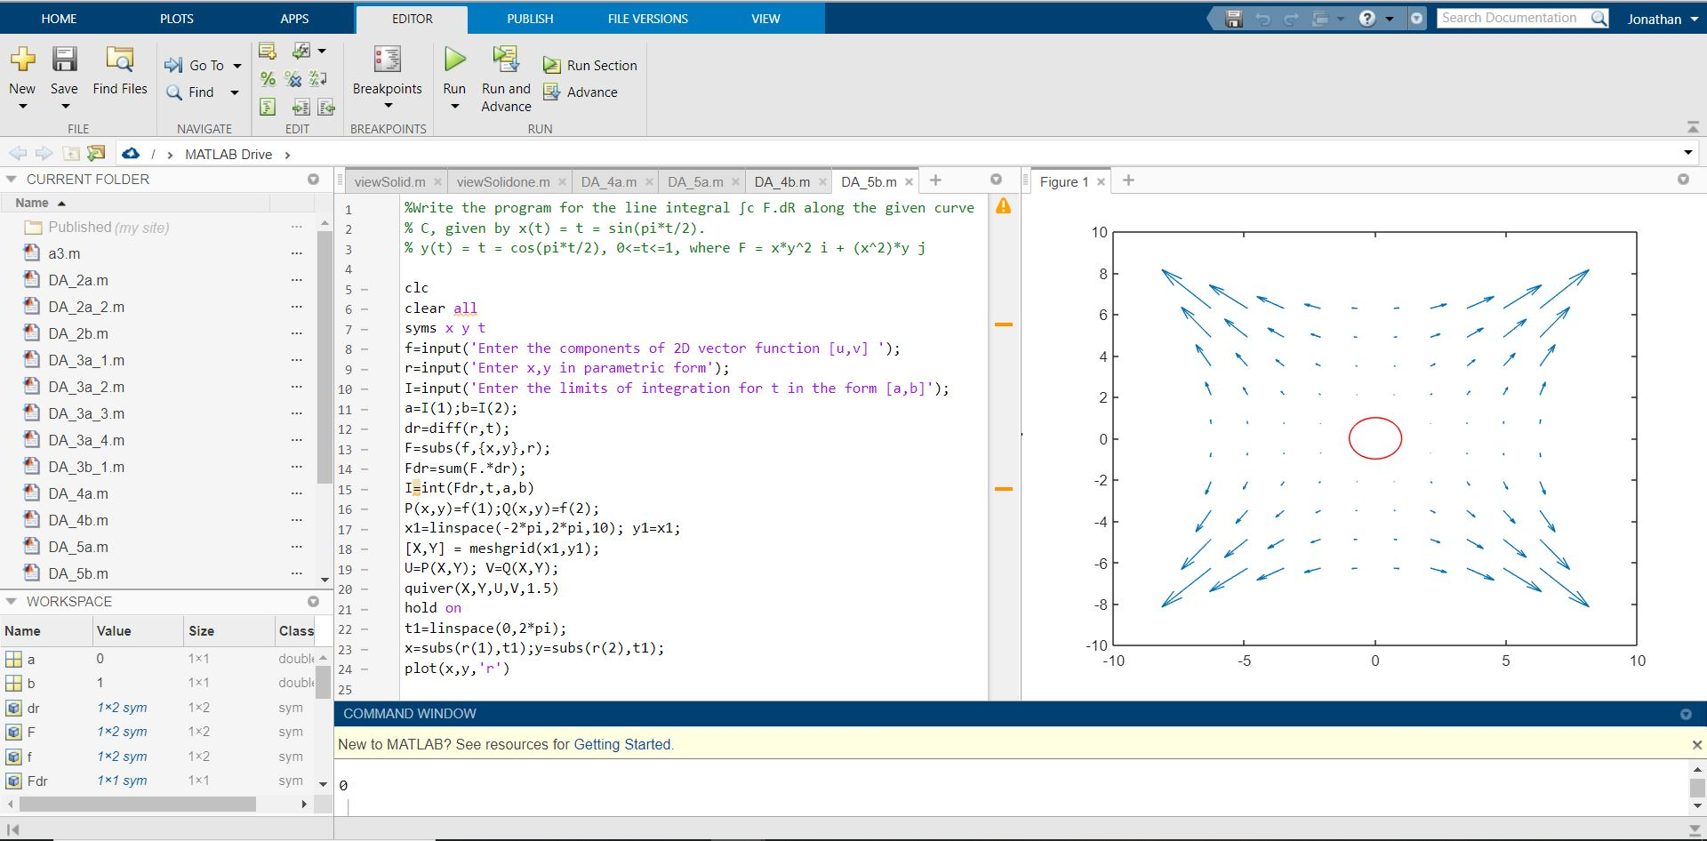

**Q1.1) Write the program for the line integral ∫c F.dR along the given curve C, given by x(t) = t + sin(pi*t/2), y(t) = t + cos(pi*t/2), 0<=t<=1, where F = x*y^2 i + (x^2)*y j. (HERE x(t) = t + sin(pi*t/2) AND y(t) = t + cos(pi*t/2), AS MENTIONED IN THE LAB MANUAL)**

A: Code is as follows:

%Write the program for the line integral ∫c F.dR along the given curve

% C, given by x(t) = t + sin(pi*t/2).

% y(t) = t + cos(pi*t/2), 0<=t<=1, where F = x*y^2 i + (x^2)*y j

clc

clear all

syms x y t

f=input('Enter the components of 2D vector function [u,v] ');

r=input('Enter x,y in parametric form');

I=input('Enter the limits of integration for t in the form [a,b]');

a=I(1);b=I(2);

dr=diff(r,t);

F=subs(f,{x,y},r);

Fdr=sum(F.*dr);

I=int(Fdr,t,a,b)

P(x,y)=f(1);Q(x,y)=f(2);

x1=linspace(-2*pi,2*pi,10); y1=x1;

[X,Y] = meshgrid(x1,y1);

U=P(X,Y); V=Q(X,Y);

quiver(X,Y,U,V,1.5)

hold on

t1=linspace(0,2*pi);

x=subs(r(1),t1);y=subs(r(2),t1);

plot(x,y,'r')

**Output (via Command Window):**

Enter the components of 2D vector function [u,v]

[x*y^2 x^2*y]

Enter x,y in parametric form

[t+sin((pi*t)/2) t+cos((pi*t)/2)]

Enter the limits of integration for t in the form [a,b]

[0,1]

I =  
   
2



